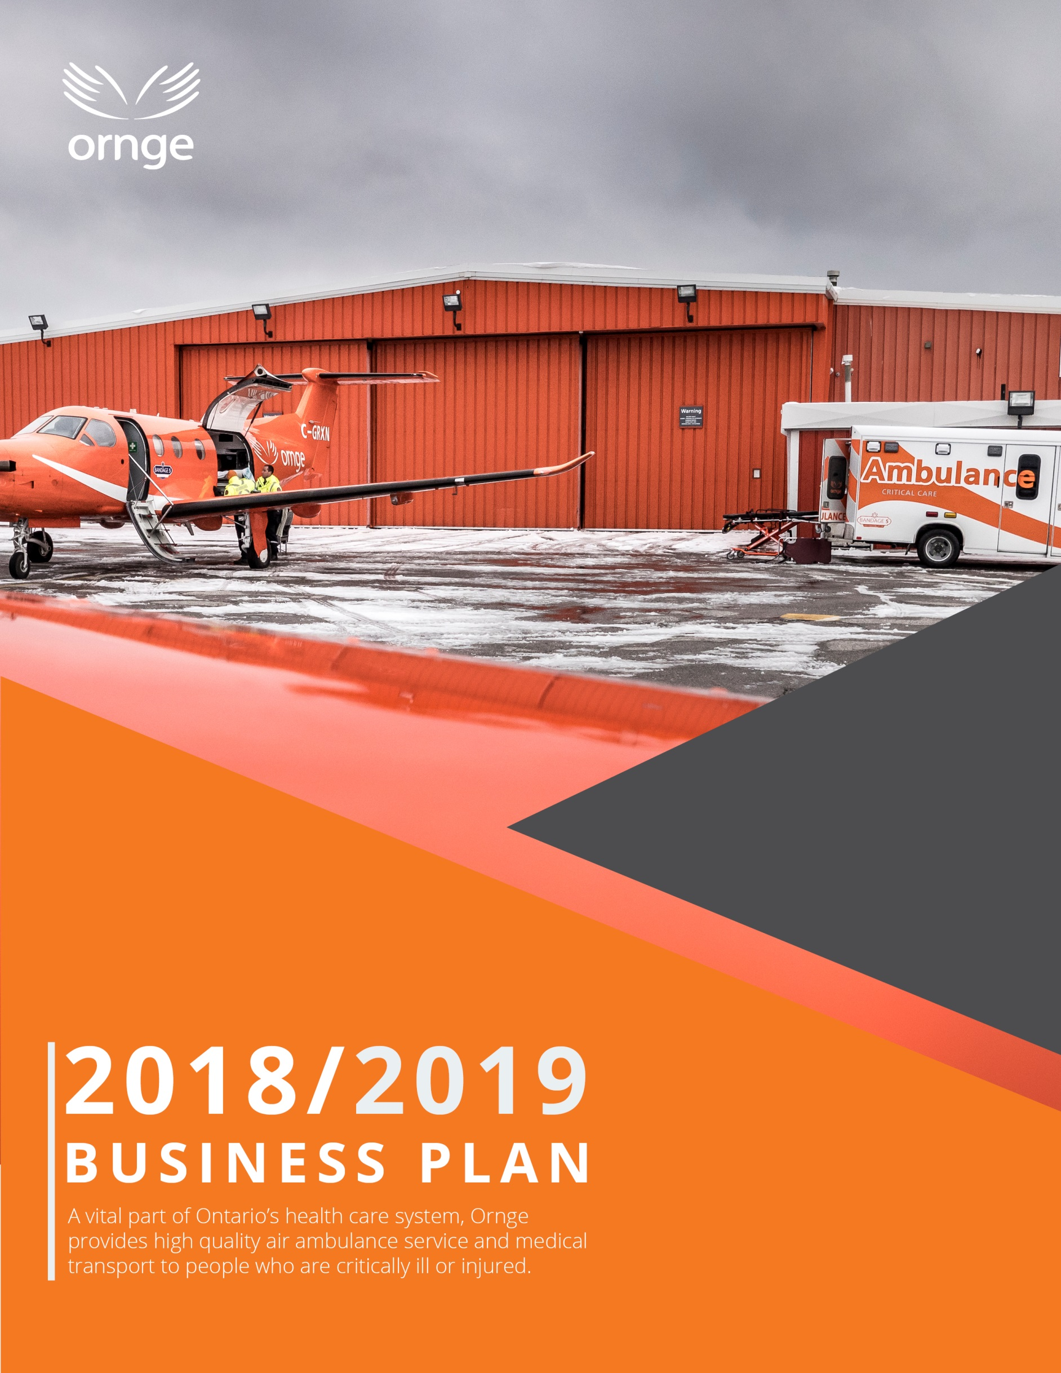

Table of Contents
Mandate 2
Operational Model 2
Strategic Directions 4
Current Operating Environment 5
Current Priorities 7
Information Technology Plan 9
Communications Plan 9
Performance Measures 9
Organizational Chart 10

Mission: To provide Ontario’s patients with safe and timely care, transport, and access to health services

Vision: A trusted and responsive partner in extending the reach of healthcare in Ontario

Values: Safety, Excellence, Integrity, Preparedness, Compassion

Mandate

About Ornge

Ornge is Ontario’s provider of air ambulance and related services. Air ambulance services are part of a province-wide system of patient care that links hospitals and communities, enabling access to specialized care for the people of Ontario. A not-for-profit charitable organization, Ornge has more than 600 employees, including paramedics, pilots, communication officers, physicians, aircraft maintenance engineers, along with a team of educators, researchers and support staff. Ornge is accountable to the Ministry of Health and Long-Term Care (MOHLTC) through a Performance Agreement, and is almost fully funded by MOHLTC.

Overview of Services

Ornge’s core business is providing timely patient transportation involving a range of paramedical services, by air and by land, including:
- Emergent and urgent interfacility transport
- Emergent scene response
- Repatriation of interfacility patients
- Non-urgent transport based on geographic and population needs
- Support for healthcare in remote communities through new and innovative approaches
- Provincial Transfer Authorization Centre (PTAC) authorization in support of public health objective
- Transportation related to organ transplant under contract with the Trillium Gift of Life Network (TGLN), Ontario’s organ and tissue donation agency.
Ornge owns and operates a fleet of fixed and rotor wing aircraft, including Leonardo AW139 helicopters, Pilatus PC-12 airplanes, and Crestline land ambulances. Service coverage extends over more than a million square kilometres into remote communities in Ontario. In total, approximately 20,000 patient-related transports are performed each year.

Operational Model

Patient care and transportation operations are delivered by highly skilled paramedics, pilots and aircraft maintenance engineers. Ornge aircraft are staffed with two pilots and two paramedics, and Ornge land ambulances are staffed with two paramedics. Services and personnel are dispatched through a central communications facility, the Operations Control Centre (OCC). The OCC works with Central Ambulance Communication Centres and sending and receiving hospitals to facilitate patient transportation. Transport Medicine Physicians are available 24/7 to provide medical guidance to paramedics in the field and to make triage decisions when there are multiple requests for resources. In addition, corporate staff provide necessary support for operations and most work out of Ornge’s head office in Mississauga.

Base Locations
Ornge has 12 bases located in 11 centres across the province from which patient care and transportation services are delivered on a 24/7 basis.

Base | Staffed Asset
Air
London | 1 Helicopter
Ottawa | 1 Helicopter
Toronto | 2 Helicopters
Sudbury | 1 Helicopter
Moosonee | 1 Helicopter
Kenora | 1 Helicopter
Thunder Bay | 1 Helicopter  2 Airplanes
Sioux Lookout | 1 Airplane
Timmins | 1 Airplane
Land
Ottawa Land | 1 Land Ambulance
Peterborough* | 1 Land Ambulance
Mississauga* | 2 Land Ambulances
*12/7

Service Delivery Partners
Ornge contracts with:
- Standing Agreement air carriers who perform fixed wing non-urgent transports and some advanced care transports largely in the North.
- Toronto Paramedic Services who deliver critical care land ambulance services within the GTA and are dispatched by Ornge’s Operations Control Centre.

In addition, for many patient transports, Ornge relies on municipal paramedic services for ground transportation between airport and hospital. Paramedic service partners are crucial to the success of Ontario’s air ambulance program.

Base Hospital
Ornge provides MOHLTC-mandated Base Hospital services, including approving training and education for paramedics, providing them with certification and medical direction, and ensuring that the quality of patient care is delivered in accordance with accepted medical practice and all applicable laws.

Third Party Relationships
In addition to our service delivery partners (noted above), Ornge works closely with provincial and federal regulators and healthcare partners, and maintains relationships with a range of stakeholders, including the Ontario Association of Paramedic Chiefs, the Paramedic Chiefs of Canada, the Ontario Base Hospital Group, Local Health Integration Networks and others. A summary of key relationships is as follows:

Ministry of Health and Long-Term Care | Regulatory and oversight relationship
Transport Canada | Regulatory relationship (fixed wing, rotor wing and maintenance)
Central Ambulance Communications Centres | Key partners in arranging patient transport
CritiCall Ontario  Critical Care Services Ontario | Key partners in initiating interfacility transport of Life or Limb patients
Hospitals and Nursing Stations | Clients - Sending and receiving facilities
Trillium Gift of Life Network | Client - Ornge is a contracted service delivery partner for the Trillium Gift of Life Network
OPSEU, OPEIU, Unifor | Union partners representing communications staff, fixed wing and rotor wing pilots, aircraft maintenance engineers and paramedics
Suppliers | E.g. aircraft and components, aviation and other maintenance services, fuel, flight simulation and training; medical equipment, consumables and pharmaceuticals, medical transport services, corporate services such as banking, communications, human resources, insurance and legal

Strategic Directions

Ornge is in the midst of implementing its Strategic Plan 2017-2020. The Plan is ambitious and includes initiatives that will be achieved in collaboration with other healthcare partners.

Goal 1: Focus our efforts and resources on activities that improve patient outcomes
Priority 1.1 Improve system access for remote First Nations communities.
Priority 1.2 Improve access to definitive care for time-sensitive patients.
Priority 1.3 Strengthen other aspects of service delivery that lead to improved patient outcomes.

Goal 2: Lead and support initiatives that improve coordination and integration with system partners
Priority 2.1 Collaborate on service improvements for special patient populations.
Priority 2.2 Further support the One Number to Call initiative.
Priority 2.3 Improve connectivity with system partners.

Goal 3: Improve service efficiency and effectiveness
Priority 3.1 Improve service utilization and reliability.
Priority 3.2 Maintain an ongoing outlook for service improvement ideas, and study ideas for long-term service and system adaptations.
Priority 3.3 Continue to work with the Ministry of Health and Long-Term Care in relation to the structural funding gap.

Goal 4: Be a learning and engaged organization
Priority 4.1 Shift culture in a positive direction so as to improve engagement and service reliability.

Current Operating Environment

Environmental Scan

Ornge monitors its operating environment for emerging trends at the interface of aviation and healthcare and adapts to changing circumstances as needed. Key factors influencing our operating environment include:
- An industry-wide fixed wing pilot shortage affecting air carriers across the country.
- New US Federal Aviation Administration requirement for a satellite transponder requiring modifications to the fixed wing and rotor wing fleets.
- Possible new industry-wide Transport Canada regulations impacting pilot duty day.
- Increasing regionalization of specialized hospital-based services (e.g. diagnostic services; stroke centres) which may increase demand for patient transportation.
- Increasing use of technology in healthcare (e.g. telemedicine, point-of-care testing devices) and procedural innovations (e.g. clot retrieval for stroke patients) which may alter transport requirements.
- Demand and capacity challenges for municipal paramedic services resulting in local delays in non-urgent patient transfers between airport and hospital.
- Concern about financial viability of some small airports.
- Health care innovations such as clot retrieval for stroke, which may alter transport requirements.

Risks and Mitigations

In keeping with Enterprise Risk Management best practices, Ornge identifies, monitors and manages risks throughout the year, with a view to minimizing the organization’s risk profile. The following table summarizes key risks:

Risk | Mitigation
Transportation Critical Event – Risk of an accident during air or land transportation. | Ornge maintains robust mitigations including extensive standardization and training programs. Initial pilot training and ongoing annual training programs are overseen by Transport Canada. Monitoring of safety standards and practices through an active safety reporting system is part of Ornge’s safety management system which is also overseen by Transport Canada. Ornge also has annual driver training program for paramedics.
Clinical Risk – Low volume, high acuity patients present a clinical risk. | Continuing medical education and simulation exercises address issues identified in clinical metrics, including high acuity skills (e.g. intubation). Chart audits are routinely performed and clinical metrics reviewed to assess compliance with clinical standards.
Unavailable to Respond to a Service Request – The main reasons why Ornge may be unable to service a request are adverse weather, volume of other requests, staffing issues and mechanical issues. | Steps are taken to deploy assets efficiently and thereby minimize the challenges associated with weather and volume. Staffing with greater certainty is a key priority. A variety of efforts are being made within labour relations processes to reduce unplanned absences, and efforts are being made to ensure frontline operations are effectively supported by head office functions, and thereby improve employee engagement. Maintenance systems and processes are in place to meet the maintenance requirements of Ornge’s fleet of fixed and rotor wing assets while minimizing downtime.
Cyber Security – Ornge is increasingly reliant on technology and information systems within its operational environments. Information holdings include Personal Health Information. | IT redundancy and disaster recovery measures are fully in place. IT security audits are performed, and systems are monitored for viruses and suspicious activity. Where real-time electronic information is used in operational environments (e.g. pilots’ weather and flight information, real-time dispatch information), back-up procedures are in place to revert to manual operations.
Annual increases in aviation and labour costs | Managing within the funding envelope requires a careful use of resources and ongoing efforts to find efficiencies within the operation, as well as maintaining an open and transparent relationship with the MOHLTC with respect to value for money and funding needs.

Key Achievements for 2017-2018

Our 2017-2018 achievements form a foundation for our 2018-2019 strategic and operational priorities. Highlights of recent achievements are as follows:

System-Level
- Expanded use of telemedicine, including a pilot project providing physician support to several remote First Nation communities.
- Ongoing collaboration with northern paramedic services and hospital partners on ways to improve time to definitive care for time-sensitive patients in the north.

Communications
- Implemented Ornge’s first deployment plan including improved triage and acuity scale.
- New process to electronically ‘push’ call details to paramedics via cell phone technology.
- Trial of satellite push-to-talk radios to improve connectivity among Ornge crews, Ornge communications centre staff, municipal land ambulance crews and Central Ambulance Communications Centres.

Transportation
- Working to address fixed wing pilot shortage through recruitment arrangement with Air Georgian Ltd. and discussions with other carriers.
- Conducted procurement process to renew Ornge’s fixed wing Standing Agreement carrier contracts.
- Introduced night vision goggles to helicopter operations including helicopter fleet modifications and pilot training.
- New long-term maintenance program for helicopter engines to minimize downtime risk.

Clinical/Base Hospital
- Successful re-accreditation of Ornge’s Critical Care Paramedic initial education program.
- Trialed new training approaches on airway management.
- Delivered peer paediatric training program for municipal land ambulance partners.
- Launched online quality improvement rounds and online annual patient safety education program.

Safety
- New helicopter flight data analysis initiative to assist with compliance to company policies and industry best practices.
- New flight risk assessment tool for pilots, continued implementation of daily crew safety briefings and annual recurrent training to reinforce safe operations.
- Initial steps for a fatigue risk management program.
- New program aimed at prevention of post-traumatic stress disorder.

Stakeholder and Public Affairs
- Launch of bilingual (English and French) new Ornge.ca external website
- Hosted two stakeholder conferences – the Canadian Aeromedical Transport conference (medical focus) and the All Canada Aeromedical Transport conference (aviation safety focus).
- Participated in numerous community events across the province.
- Profiles and news articles in leading aviation industry trade publications.
- Donated the hulls of Ornge’s retired helicopter fleet to several community colleges.
- New website with updated information and improved user experience.
- Introduced Ornge’s first dress uniforms.
- Celebrated 40th anniversary of Ontario’s air ambulance program with public golf tournament, a staff and stakeholder event, and commemorative decaling of the aircraft under original “Bandage” name from the early history of the air ambulance program.

Current Priorities

Priorities for 2018-2019 include operational initiatives related to transportation, clinical and communications services, together with corporate support services. Key priorities are as follows:

System-Level
- Expand use of telemedicine in support of improved access to healthcare for remote First Nation communities and patients in small northern hospitals. Introduce paediatric support.
- Continue collaboration with northern paramedic services and hospital partners on ways to improve time to definitive care for time-sensitive patients in the north.
- Ongoing focus on data analytics and reporting in support of evidence-based decision making.
- Participate in MOHLTC’s anticipated expansion of the One Number to Call initiative and integration of air ambulance and municipal paramedic service dispatch platforms.

Communications
- Implement an electronic status board for hospitals to view the status and ETA of their patient’s transportation.
- Further consider improved crew communication and coordination with system partners.

Transportation
- Software upgrades for fixed wing and rotor wing fleets with improved safety and efficiency features.
- Continue rotor wing flight data monitoring and initiate a fixed wing flight data monitoring program.
- Continued focus on just culture.
- Complete RFP process with the goal of modifying the rotor wing fleet to provide a roll on stretcher solution and accommodate incubators newly in use in children’s hospitals.
- Improve transportation logistics for bariatric patients through improved coordination with system partners and by adapting equipment and procedures.

Clinical/Base Hospital
- New infusion pumps to address manufacturer’s impending withdrawal of support for current pump.
- Continued focus on encouraging utilization of critical care land transportation by hospital partners.
- Increase delivery of paramedic training at bases through physician-led in-aircraft simulation.
- Further explore technology-guided competency based-education for initial and continuing paramedic education emphasizing system, regional and individual needs.
- Preparation of an integrated quality and patient safety plan.

Safety
- Continue implementing the flight risk assessment tool, daily crew briefings and annual recurrent training to reinforce safe operations.
- Leasehold improvements at operational bases to address issues associated with aging buildings.
- Further implement the post-traumatic stress disorder prevention program and initiate work on a new Occupational Health and safety management system.

Stakeholder and Public Affairs
- Continued focused contributions to stakeholder and industry conferences, community events and trade publications.
- Ongoing efforts to educate stakeholders on provincial standards for use of air ambulance resources

Information Technology Plan

The primary IT goal is to support frontline operations by maintaining 24/7 communication links and business applications. Within this context, cyber security is a high priority.

A variety of improvement projects are in process, and desired outcomes include:
- Improved system integration with healthcare partners, including integration of land ambulance and air ambulance dispatch systems (under the leadership of MOHLTC).
- Improved communications among Ornge’s Operations Control Centre, pilots, paramedics, and service delivery partners (Central Ambulance Communications Centres and municipal paramedic services).
- Improved internal systems to enhance data quality and timeliness and support operational streamlining.

Communications Plan

In terms of external communication, our focus is on showcasing air ambulance and critical care land ambulance services through patient stories. Hearing a personal story of how Ornge impacted someone’s life in a positive way is impactful and brings colour to our mission of serving patients. In addition, relationships with government and healthcare partners and stakeholders remain a priority, as do media and public relations.

In terms of internal communication, our focus is on initiatives and outreach activities that support the mission, better recognize employee contributions, and improve two-way communication. The aim is to strengthen and exemplify our corporate culture, while at the same time improve employee engagement by building on the pride that revolves around serving Ontario’s patients.

Performance Measures

Ornge prepares a quality improvement plan every year, following the guidelines set by Health Quality Ontario. Highlights are as follows:

Performance Indicator | 2017-2018 Target
Patient Satisfaction: % of respondents who selected a positive score in response to the question: “Overall how would you rate the quality of care you received from Ornge?” | >98%
Healthcare Partner Satisfaction: % of management respondents who selected a positive score in response to the question: “Taking into account all the ways you have had contact with Ornge, overall how satisfied are you with those experiences?” | >85%
Clinical Quality: Provision of analgesia for trauma patients so that patients experience minimal pain during transport | 90%
Resource Availability: % availability of aircraft, pilot staff and paramedic staff resources all at the same time | 90%
Staff Safety: Reduce the total number of WSIB Lost Time and No Lost Time injuries and illness as per provincial formula | <5.60 incidents per 100 employees

Organizational Chart
Board of Directors
President & Chief Executive Officer
Andrew McCallum
Chief Operating Officer and Deputy CEO
Robert Giguere

Chief Medical Officer
Homer Tien

Interim Chief Financial Officer
Inna Kravitz
Chief Human Resources Officer
Foster Brown
General Counsel and Corporate Secretary
Susan Kennedy

Director Communications and Public Affairs
James MacDonald
Director Strategic Planning, Gvt and Stakeholder Relations
Jennifer Young

Central Ambulance Communications Centres are the dispatch centres for municipal land ambulances.
One Number to Call aims to reduce time required for hospital staff to coordinate patient transfer, add consistency to the transport selection process, build understanding of when, and if, regional variations are necessary and appropriate, and build an understanding and track the utilization of hospital escorts.
A culture in which front line operators or other persons are not punished for actions, omissions or decisions made by them that are commensurate with their experience and training but in which gross negligence, willful violations or destructive acts are not tolerated.

