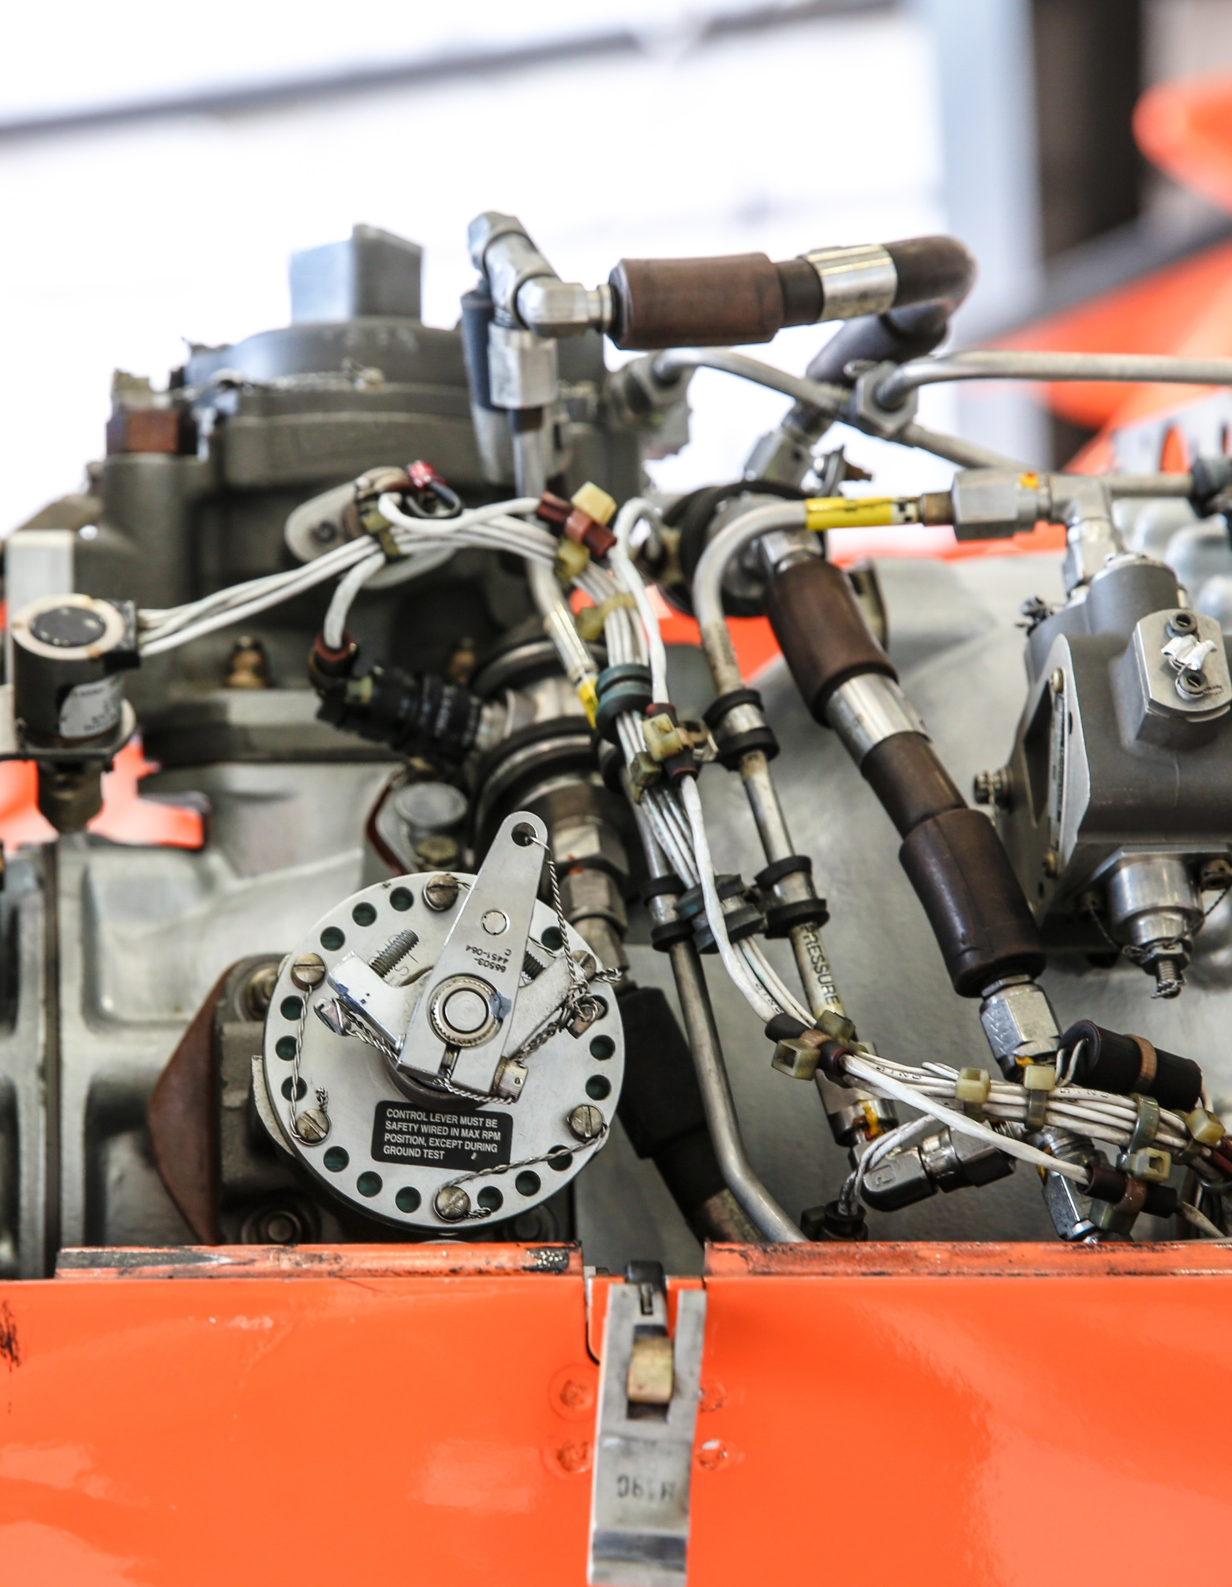
Ornge
2019/2020
Business Plan
A vital part of Ontario’s healthcare system, Ornge provides high quality air ambulance service and medical transport to people who are ill and critically injured.

Table of Contents
Mandate 1
Operational Model 1
Strategic Directions 3
Current Operating Environment 3
Key Achievements for 2018-2019 5
Key Priorities for 2019-2020 7
Information Technology Plan 8
Communications Plan 8
Performance Measures 9
Organizational Chart 10

Mission: To provide Ontario’s patients with safe and timely care, transport, and access to health services

Vision: A trusted and responsive partner in extending the reach of healthcare in Ontario

Values: Safety, Excellence, Integrity, Preparedness, Compassion

Mandate

About Ornge

Ornge is Ontario’s provider of air ambulance and related services. Air ambulance services are part of a province-wide system of patient care that links communities to hospitals, enabling access to specialized care for the people of Ontario. A not-for-profit charitable organization, Ornge has more than 600 employees, including paramedics, pilots, communication officers, aircraft maintenance engineers, along with a team of educators, researchers and support staff. Ornge is accountable to the Ministry of Health and Long-Term Care (MOHLTC) through a Performance Agreement, and is almost exclusively funded by MOHLTC.

Overview of Services

Ornge’s core business is providing timely patient transportation involving a range of paramedical services, by air and by land, including:
- Emergent and urgent interfacility transport
- Emergent scene response
- Repatriation of interfacility patients
- Non-urgent transport based on geographic and population needs
- Support for healthcare in remote communities through new and innovative approaches
- Provincial Transfer Authorization Centre (PTAC) authorization in support of public health objective
- Transportation related to organ transplant under contract with the Trillium Gift of Life Network (TGLN), Ontario’s organ and tissue donation agency.
Ornge owns and operates a fleet of fixed and rotor wing aircraft, including Leonardo AW139 helicopters, Pilatus PC-12 airplanes, and Crestline land ambulances. Service coverage extends over more than a million square kilometres into remote communities in Ontario. In total, approximately 20,000 patient-related transports are performed each year.

Operational Model

Patient care and transportation operations are delivered by highly skilled paramedics, pilots, communications officers and aircraft maintenance engineers. Ornge aircraft are staffed with two pilots and two paramedics, and Ornge land ambulances are staffed with two paramedics. Services and personnel are dispatched through a central communications facility, the Operations Control Centre (OCC). The OCC works with Central Ambulance Communication Centres and sending and receiving hospitals to facilitate patient transportation. Transport Medicine Physicians are available 24/7 to provide medical guidance to paramedics in the field and to make triage decisions when there are multiple requests for resources. In addition, corporate staff provide necessary support for operations and most work out of Ornge’s head office in Mississauga.
Base Locations
Ornge has 12 bases located in 11 centres across the province from which patient care and transportation services are delivered on a 24/7 basis.

Base | Staffed Asset
Air
London | 1 Helicopter
Ottawa | 1 Helicopter
Toronto | 2 Helicopters
Sudbury | 1 Helicopter
Moosonee | 1 Helicopter
Kenora | 1 Helicopter
Thunder Bay | 1 Helicopter  2 Airplanes
Sioux Lookout | 1 Airplane
Timmins | 1 Airplane
Land
Ottawa Land | 1 Land Ambulance
Peterborough | 1 Land Ambulance
Mississauga | 2 Land Ambulances

Service Delivery Partners
Ornge contracts with:
- Standing Agreement air carriers who perform non-urgent transports and some advanced care transports by airplane, largely in the North.
- Toronto Paramedic Services who deliver critical care land ambulance services within the GTA and are dispatched by Ornge’s Operations Control Centre.

In addition, for many patient transports, Ornge relies on municipal paramedic services for ground transportation between airport and hospital. Paramedic service partners are crucial to the success of Ontario’s air ambulance program.

Base Hospital
Ornge provides MOHLTC-mandated Base Hospital services, including approving training and education for paramedics, providing them with certification and medical delegation, and ensuring that the quality of patient care is delivered in accordance with accepted medical practice and all applicable laws.

Third Party Relationships
In addition to our service delivery partners (noted above), Ornge works closely with provincial and federal regulators and healthcare partners, and maintains relationships with a range of stakeholders, including the Ontario Association of Paramedic Chiefs, the Paramedic Chiefs of Canada, the Ontario Base Hospital Group, Local Health Integration Networks and others. A summary of key relationships is as follows:

Ministry of Health and Long-Term Care | Regulatory and oversight relationship
Transport Canada | Regulatory relationship (helicopter and airplane operations, and maintenance)
Central Ambulance Communications Centres | Key partners in arranging patient transport
CritiCall Ontario  Critical Care Services Ontario | Key partners in initiating interfacility transport of Life or Limb patients
Hospitals and Nursing Stations | Clients - Sending and receiving facilities
Trillium Gift of Life Network | Client - Ornge is a contracted service delivery partner for the Trillium Gift of Life Network
OPSEU, OPEIU, Unifor | Union stakeholders representing communications staff, helicopter and airplane pilots, aircraft maintenance engineers and paramedics
Suppliers | E.g. aircraft and components, aviation and other maintenance services, fuel, flight simulation and training; medical equipment, consumables and pharmaceuticals, medical transport services, corporate services such as banking, communications, human resources, insurance and legal

Strategic Directions

Ornge is in the midst of implementing its Strategic Plan 2017-2020. The Plan is ambitious and includes initiatives that will be achieved in collaboration with other healthcare partners.
Goal 1: Focus our efforts and resources on activities that improve patient outcomes
Goal 2: Lead and support initiatives that improve coordination and integration with system partners
Goal 3: Improve service efficiency and effectiveness
Goal 4: Be a learning and engaged organization

Current Operating Environment

Environmental Scan

Ornge monitors its operating environment for emerging trends at the interface of aviation and healthcare and adapts to changing circumstances as needed. Key factors influencing our operating environment include:
- A global airplane pilot shortage affecting air carriers across the country.
- Future Transport Canada rules on pilot duty day and crew resource management.
- Growing concern about financial viability of small municipal airports with some at risk of closure
- Evolution within the healthcare system -- increasing regionalization of specialized hospital-based services (e.g. diagnostic services), increasing use of technology in healthcare (e.g. telemedicine, point-of-care testing devices) and procedural innovations (e.g. clot retrieval for stroke patients) – all of which may alter transport patterns and requirements.
- Increasing demand for repatriation from specialized treatment hospitals to community hospitals, including non-urgent transports requiring advanced/critical care (i.e. ICU to ICU repatriations to home hospitals).
- Demand and capacity challenges for municipal paramedic services resulting in local delays in non-urgent patient transfers between airport and hospital.

Risks and Mitigations

In keeping with Enterprise Risk Management best practices, Ornge identifies, monitors and manages risks throughout the year, with a view to minimizing the organization’s risk profile. Summary of certain risks as they pertain to operations:

Risk | Mitigation
Transportation Critical Event – Risk of an accident during air or land transportation. | Ornge maintains robust mitigations including extensive standardization and training programs. Initial pilot training and ongoing annual training programs are overseen by Transport Canada. Monitoring of safety standards and practices through an active safety reporting system is part of Ornge’s safety management system which is also overseen by Transport Canada. For land transportation, driver training is provided.
Unavailable to Respond to a Service Request – The main reasons why Ornge may be unable to service a request are adverse weather, volume of other requests, staffing issues and mechanical issues. | Steps are taken to deploy assets efficiently and thereby minimize the challenges associated with volume and weather. Systems and processes are in place to plan routine maintenance and minimize downtime associated with aircraft maintenance. Staffing with certainty is a key priority. An On Call staffing model was introduced to help address unplanned absences. In response to the global fixed wing (airplane) pilot shortage, recruitment activities are continual.
Clinical Risk – Low volume, high acuity patients present a clinical risk. | Continuing medical education and simulation exercises address issues identified in clinical metrics, including high acuity skills. Chart audits are routinely performed and clinical metrics reviewed to assess compliance with clinical standards.
Cyber Security – Ornge is increasingly reliant on technology and information systems within its operational environments. Information holdings include Personal Health Information. | Various IT security measures are taken, including perimeter security such as firewalls and network access controls. Systems are monitored for viruses and suspicious activity and security audits are performed. IT redundancy and disaster recovery measures are in place. Procedures are also in place to revert to manual operations where real-time electronic information is used.
Future Cost Increases | Managing within the funding envelope requires a careful use of resources and ongoing efforts to find efficiencies within the operation, as well as maintaining an open and transparent relationship with the MOHLTC with respect to value for money and funding needs.

Key Achievements for 2018-2019

Throughout the year, Ornge was focused on preparing for, and successfully completed, several independent reviews:
- In its first bid for accreditation, Ornge was awarded Exemplary status by Accreditation Canada. This is the highest level of accreditation.
- Service Reviews were conducted by MOHLTC on Ornge’s air and land ambulance services, Operations Control Centre and Base Hospital with successful outcomes.
- Ornge’s Critical Care Paramedic initial education program was successfully reaccredited.
In addition, key strategic and operational achievements for the year were as follows:

Service to Patients
- Implemented Asset Selection Guidelines for Bariatric Patients for improved transport logistics and better coordination with system partners.
- Implemented new procedures for the Transfer of Agitated Patients to ensure the patient is transported in a medically appropriate manner while maintaining safety during flight.
- Completed the first ECMO patient transport by airplane.
- Implemented a peak hours trial by adjusting the hours of service of two Ornge airplanes from night shift to afternoon shift, to more closely match service availability with demand, particularly in northern Ontario.
- Implemented a trial with a Standing Agreement carrier to provide Advanced Care Paramedic Land (ACP Land) level of care for certain stable patients, which aims to optimize availability of Ornge’s service.
- Expanded Ornge’s telemedicine program to include pediatrics.
- Expanded iSTAT program to include all federal nursing stations.
- Improved staffing with certainty through the collective bargaining process – improved negotiated terms and conditions of employment to improve productive staff hours and reduce late starts.

Clinical/Base Hospital
- Completed the first year of technology-guided competency-based education for paramedic initial and continuing medical education.
- Trialed airway management training using human cadavers; partnering with several schools of anatomy. Completed RFP for video laryngoscopes for airway management.
- Created two new Standards Paramedic positions and re-shaped the Chief Paramedic’s duties to reflect the operational focus on safety, engagement and standards.
- Implemented software improvements to the Electronic Patient Care Record to support improved user experience and decreased documentation times.
- Hosted the Annual General Meeting for all provincial Base Hospitals.
- Prepared a three-year Quality and Patient Safety Strategic Plan with initiatives to improve timeliness and effectiveness, improve on patient-centred care, and make care more efficient and safe.

Transportation
- Continual pilot recruitment efforts in response to the ongoing global fixed wing (airplane) pilot shortage.
- Significant progress toward finalizing third-generation medical interior. Completed procurement for a powered stretcher loader system. Leased a 12th helicopter to facilitate installation of this system and fleet repainting. Completed modifications on the 12th helicopter to enable night vision goggle operations.
- Installed avionics updates on the helicopter fleet and a flight data monitoring system that wirelessly sends flight data to support maintenance planning and reduce operating costs.
- Completed the first wing-to-fuselage attachment inspection (a high-competency maintenance task).

Logistics/Communications
- Introduced a new Patient Transfer Status Board to hospital partners displaying real-time estimated arrival times to the landing location from Ornge’s dispatch system.
- Modernized the Provincial Transfer Authorization Centre (PTAC) application by discontinuing faxes.
- Implemented call-taking process improvements, including a Non-Urgent booking desk with a callback option to improve availability for responding to Emergent requests and reduce hospital staff time spent ‘on hold’.
- Implemented a new portal for air carriers supporting the Trillium Gift of Life Network program.

Technology, Equipment, Facilities
- Commenced phased implementation of new Workforce software.
- Implemented a new Learning Management System to support employee training.
- Dealt with numerous supply chain challenges including industry-wide medication and consumable shortages and equipment obsolescence.
- Made various leasehold improvements to address issues associated with aging facilities, with positive impact on employee engagement.

Safety
- Hosted the second annual All Canadian Aeromedical Transport conference (aviation safety focus).
- Completed implementation of Ornge’s PTSD Prevention and Support Plan, including implementation of a new Traumatic Incident Review Procedure.
- Implemented a new paramedic driver training program.
- Formally embraced the Just Culture philosophies in corporate policies.

Stakeholder, Public and Employee Engagement
- New Landing Site Safety video for first responders to promote safety around the helicopter
- Participated in numerous community events across the province.
- Arranged numerous patient reunions at bases across the province and at head office.
- Significant internal focus on leadership development.
- New internal publication on Living Our Values at Ornge.
- Partnership with Contact North providing staff with new self-selected virtual learning opportunities.
- New social committee at head office.

Key Priorities for 2019-2020

Priorities for 2019-2020 include operational initiatives related to transportation, clinical and communications services, together with corporate support services. Highlights are as follows:

Service to Patients
- Continue peak hours staffing model at the Sioux Lookout and Timmins bases, with ongoing analysis in relation to demand.
- Enhance transport capability for bariatric patients through modification of the helicopter medical interior.
- Develop improved parameters for ECMO patient transfer by air.
- Expand the use of telemedicine to further support access to healthcare in the North.

Clinical/Base Hospital
- Expand the cadaver lab airway management training program for paramedic initial certification.
- Analyze the possibility of carrying blood on board the aircraft, and consider other technology and processes improvements.
- Continue with refreshing the Base Hospital’s medical directives and airway management algorithm.
- Continue toward Ornge’s long-term goal of single level of care at the Critical Care Paramedic level.

Transportation
- Ongoing pilot recruitment in response to the ongoing global fixed wing (airplane) pilot shortage.
- Numerous extraordinary aircraft maintenance tasks including:
  - Installing the powered stretcher loading system on the rotor wing fleet
  - Repainting of the rotor wing fleet
  - Wing-to-fuselage attachment inspections on the airplane fleet.
- Standardize the arrangement of consumables and other aspects of the medical interior in each fleet type – helicopter, airplane and land ambulance.

Logistics/Communication
- Implement new telephone routing in the Operations Control Centre prioritizing calls from the initial menu selection (e.g. Press one for Scene Call).
- Implement a new technology-enabled decision support tool to improve operational efficiency.
- Streamline the call intake process for hospitals requesting inter-facility patient transfers.

Technology and Equipment
- Field test and implement new infusion pumps and video laryngoscopes.
- Take steps toward implementing a new ventilator.
- Continue with phased implementation of Workforce software.
- Introduce an effective video/audio/presentation means of business communication in support of reduced travel.

Safety
- Further implement the hazard prevention program.
- Develop a new Occupational Health and Safety Management System.
- Trial two sleep pods to assess effectiveness as a mitigation for fatigue.
- Further work on operational standardization initiatives taking a multidisciplinary approach (aircraft maintenance, safety, dispatch, and helicopter and airplane operations).
Stakeholder, Public and Employee Engagement
- Ongoing focus on leadership development, including frontline supervisory roles, and succession planning.
- Extend Ornge’s patient survey to include patients carried by Standing Agreement Carrier partners.
- Place a renewed focus on stakeholder education, including outreach and educational materials such as:
  - Video for community organizations interested in building a helipad to explain Ornge’s operational requirements.
  - Training videos for EMS partners on the Field Trauma Triage and Air Ambulance Utilization.
  - Improved materials for hospital partners on Preparing a Patient for Transport and information for Medical Escorts.
- Continued focused participation at industry events, community events and in trade publications.

Information Technology Plan

The primary IT goal is to support frontline operations by maintaining 24/7 communication links between the Operations Control Centre (OCC) and a range of stakeholders, including our crews, Transport Medicine Physicians, sending and receiving healthcare facilities, Central Ambulance Communications Centres, EMS services and other healthcare service providers. Ornge manages a range of technology tools, including:
- Dispatch software, including decision support software
- Dispatch telecommunication technology, including telephony
- Data base platforms

In addition, Ornge manages a range of business applications that support administrative functions. Business continuity and cyber security remain the highest priority.

In the coming year, the main areas of focus will be:
- System improvements that support operational efficiency.
- System integration with healthcare partners. Steps will be taken toward developing a portal for hospitals to initiate same-day patient transports.
- Long-term technology planning. A planning process will be undertaken to identify Ornge’s evolving technology needs and strategic opportunities.
- Maintaining and enhancing disaster recovery capabilities.
- Improved technology for communication with frontline and other service providers.

Communications Plan

Ornge’s Corporate Communications and Public Affairs is a team of professional communicators which provides responsive, proactive and reactive communications advice and support to internal stakeholders, promotes the organization as a leading provider of air ambulance and related services, and engages external audiences and stakeholders to build awareness and understanding of our work.

Current Strategic Communication Priorities

- Internal engagement: Corporate communications will work with internal groups on various initiatives aimed at enhancing the organization’s corporate culture. The objective of such programs, publications and outreach activities will be to build support for the mission, enhance morale, and open up new channels of two-way communication. This includes formal recognition programs, employee and employee group spotlights (including www.ornge.ca/flywithus, a recruitment-focused campaign page), and employee-focused video content (such as livestreamed town hall meetings and animated whiteboard videos.)

- Patient stories: We will be highlighting patient story campaigns in order to connect with the people we serve and share their stories with our staff and stakeholders. Building relationships with past patients is challenging for Ornge, as they are often with us for a relatively short period of time and we are not always able to learn the outcome. However, hearing a personal story of how Ornge impacted someone’s life in a positive way is impactful and brings colour to Ornge’s mission of serving patients. New patient story videos continue to gain large audiences on social media providing inspiration for Ornge staff and helping the public understand Ornge’s role in the healthcare system

- Events: Ornge attendance at community events provides a unique opportunity for the public to learn more about our service. We participate in a variety of ways: positioning an active crew to a community event, delivering a presentation on Ornge services to community groups, and maintaining a presence at an industry or public trade show. Corporate Communications seeks to leverage new technologies to improve our outreach capabilities, including a new ‘virtual reality tour’ of Ornge facilities and aircraft.

- Government Communications: Finally, maintaining a productive and collaborative relationship with the Ministry of Health and Long-Term Care (MOHLTC) continues to be a priority, and an important way of demonstrating Ornge’s commitment to accountability and transparency.

Performance Measures

Ornge prepares a quality improvement plan every year, following the guidelines set by Health Quality Ontario. Highlights are as follows:

Performance Indicator | 2018-2019 Target
Patient-Centred Care: % of respondents who selected a positive score in response to the question: “Overall how would you rate the quality of care you received from Ornge?” | >99%
Equitable Care: Rate of transport of accompanying family member for pediatric patients (<16 yrs) from air-only accessible communities | 100%
Effective Care: Provision of appropriate analgesia for trauma patients so that patients experience minimal pain during transport | 90%
Efficient Care: % availability of aircraft, pilot staff and paramedic staff resources all at the same time | 90%
Staff Safety: Reduce the total number of WSIB Lost Time and No Lost Time injuries and illness as per provincial formula | <5.50 incidents per 100 employees

Organizational Chart

Central Ambulance Communications Centres are the dispatch centres for municipal land ambulances.
The Sioux Lookout and Timmins bases are staffed using a peak hours model, with 24 service hours. Peterborough and Mississauga land ambulances are 12/7.
Extracorporeal Membrane Oxygenation is heart/lung bypass requiring special equipment and hospital staff.
iSTAT is a handheld blood analyzer.
A culture in which front line operators or other persons are not punished for actions, omissions or decisions made by them that are commensurate with their experience and training but in which gross negligence, willful violations or destructive acts are not tolerated.

